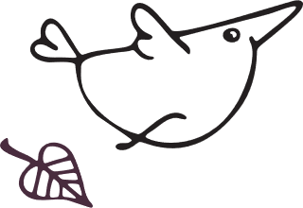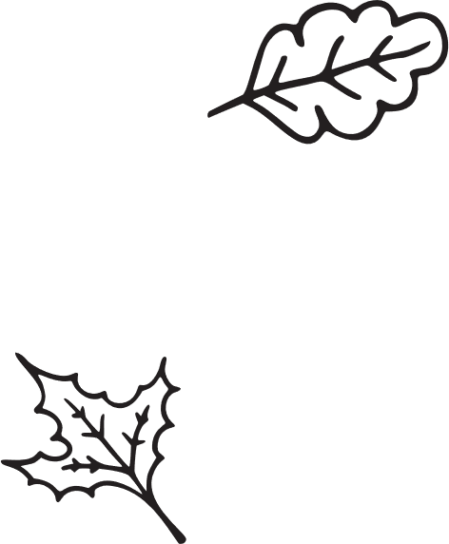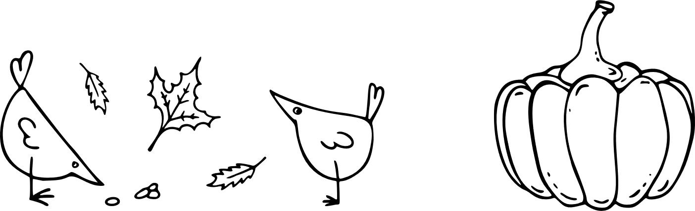

|  |
| --- |
| ThanksgivingParty Menu |
| Appetizer Select the text to update it with your own. Use this space to add a description of your food or your appetizer options. The appetizer is usually the smallest portion and served before the meal starts. (Example: Cheese, fruit plate, or any type of finger food.) First Course Select the text to update it with your own. Use this space to add a description of your food or your first course options. The first course is lighter than your main course. (Example: Salad.)   Main Course Select the text to update it with your own. Use this space to add a description of your food or your main course. The main course is usually the largest portion. (Hint: If you’re serving a meat option, don’t forget to include a vegetarian/vegan option too.) Sides Select the text to update it with your own. Use this space to add a description of your food or your side options. The side is usually a cooked vegetable. (Example: Green beans, corn, potatoes, and more.) Desserts Select the text to update it with your own. Use this space to add a description of your food or your dessert options. The dessert can be served hot or cold. (Example: ice cream, fruit, dessert wine, and more.) |

|  |  |  |
| --- | --- | --- |
| ThanksgivingParty Menu |  |  |
| grapes |  | pumpkin |
| APPETIZER Select the text to update it with your own. Use this space to add a description of your food or your appetizer options. The appetizer is usually the smallest portion and served before the meal starts. (Example: Cheese, fruit plate, or any type of finger food.) |  | FIRST COURSE Select the text to update it with your own. Use this space to add a description of your food or your first course options. The first course is lighter than your main course. (Example: Salad.) |
| turkey |  | carrot |
| MAIN COURSE Select the text to update it with your own. Use this space to add a description of your food or your main course. The main course is usually the largest portion. (Hint: If you’re serving a meat option, don’t forget to include a vegetarian/vegan option too.) |  | SIDES Select the text to update it with your own. Use this space to add a description of your food or your side options. The side is usually a cooked vegetable. (Example: Green beans, corn, potatoes, and more.) |
|  |  | pie |
|  |  | DESSERTS Select the text to update it with your own. Use this space to add a description of your food or your dessert options. The dessert can be served hot or cold. (Example: ice cream, fruit, dessert wine, and more.) |

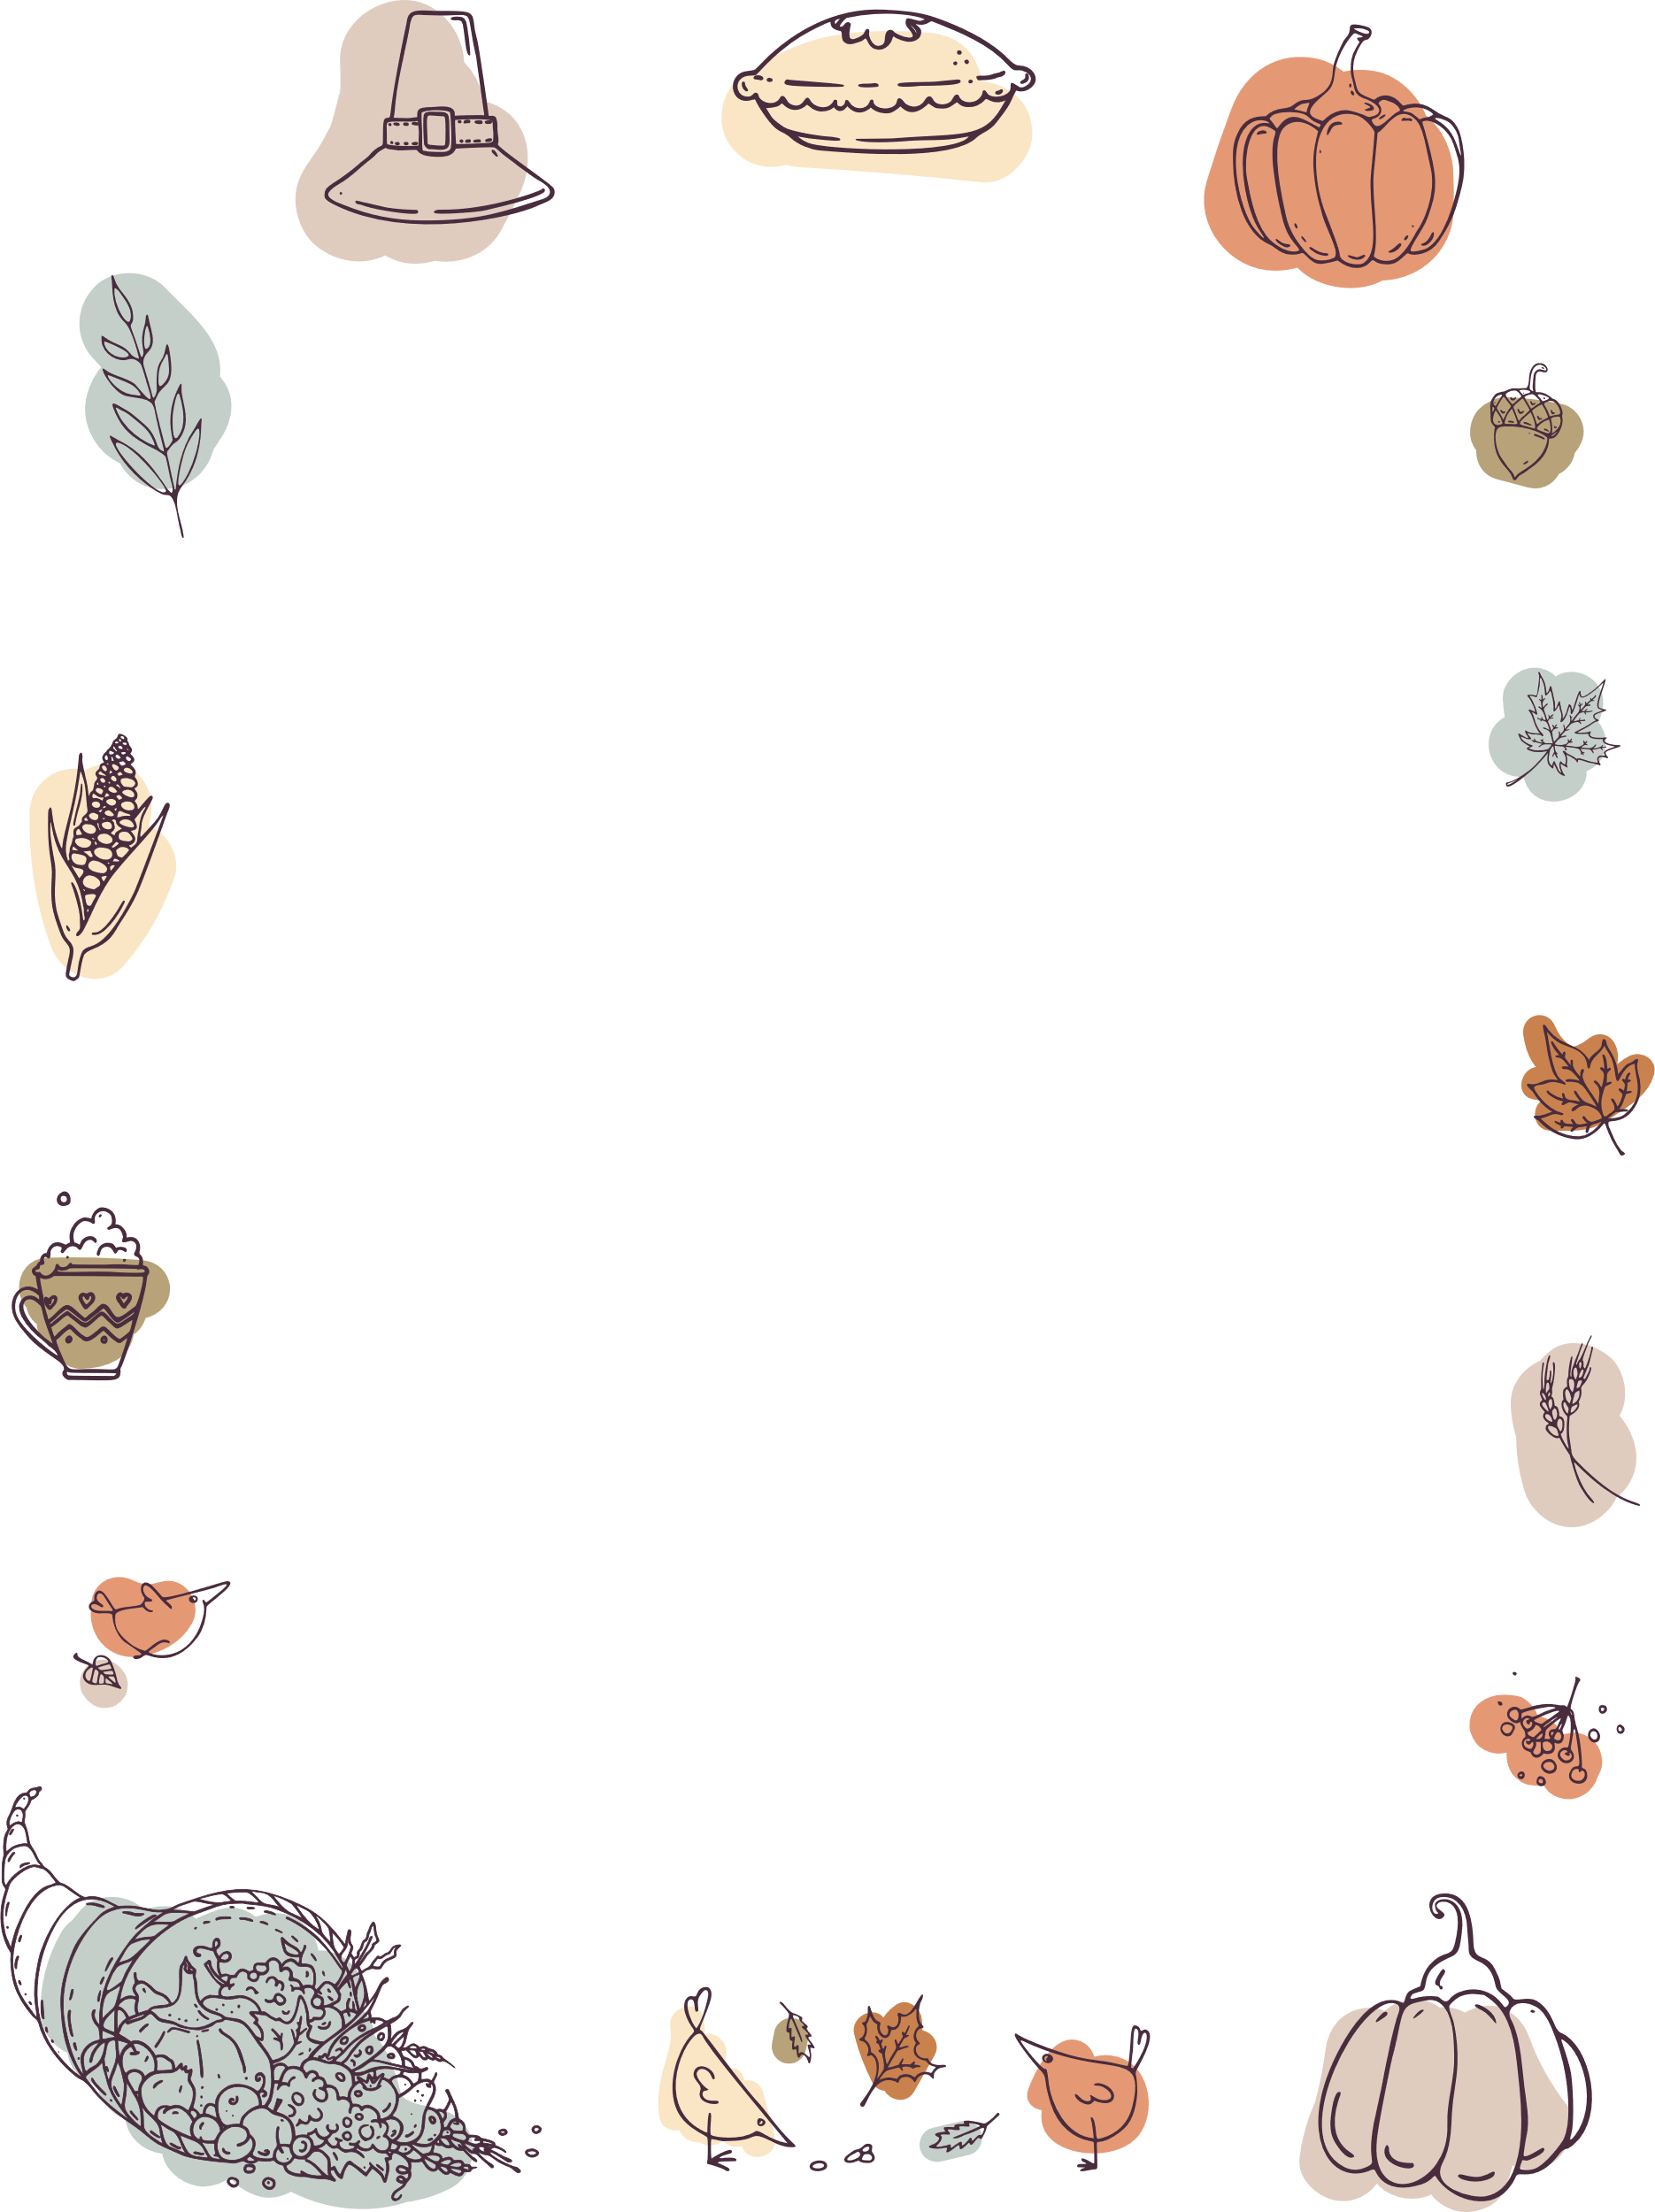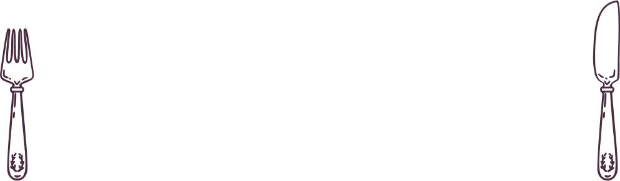

|  |
| --- |
| ThanksgivingParty Menu |
| Appetizer Select the text to update it with your own. Use this space to add a description of your food or your appetizer options. The appetizer is usually the smallest portion and served before the meal starts. (Example: Cheese, fruit plate, or any type of finger food.) First Course Select the text to update it with your own. Use this space to add a description of your food or your first course options. The first course is lighter than your main course. (Example: Salad.)   Main Course Select the text to update it with your own. Use this space to add a description of your food or your main course. The main course is usually the largest portion. (Hint: If you’re serving a meat option, don’t forget to include a vegetarian/vegan option too.) Sides Select the text to update it with your own. Use this space to add a description of your food or your side options. The side is usually a cooked vegetable. (Example: Green beans, corn, potatoes, and more.) Desserts Select the text to update it with your own. Use this space to add a description of your food or your dessert options. The dessert can be served hot or cold. (Example: ice cream, fruit, dessert wine, and more.) |